SOFTCOM S.A.
Republica Moldova, Chişinău MD-2038, bd. Decebal, 76
Tel/Fax (+37322)563306; www.syscom.md

AUTOMATED MONITORING SYSTEM OF VERTICALITY AND DYNAMIC PARAMETERS OF MASTS / TOWER
ASVD
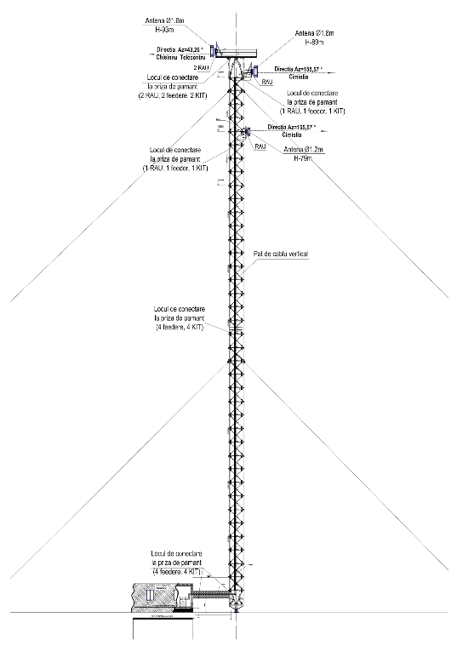
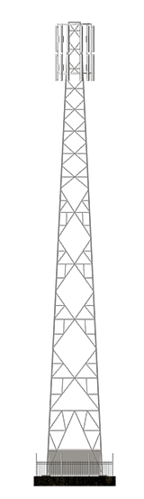

2021 г.

Purpose and main functions

ASVD is intended for automated control of verticality and dynamic parameters of real time masts / towers of TV-radio antenna devices etc.

The main functions of ASVD:
- Comprehensive real-time (on-line) remote monitoring of masts / towers.
- Automatic real time acquisition of verticality diagrams of masts / towers.
- Real-time monitoring of vibrations of masts / towers under the influence of external conditions (wind, hurricane, earthquakes, passage of heavy equipment, etc.)
- Obtaining data and reports for previous time periods (up to a year or more) and comparing them with current ones in order to determine the temporary degradation.
- Displaying information about the location of masts / towers on the geographic information map and their status.
- Convenient graphic and reporting forms for the Dispatcher and Administrator.
- Providing engineering and technical personnel with real-time information about the condition of masts / towers during work to restore verticality and eliminate excess vibrations.

Composition and architecture

The general architecture of ASVD is shown in Fig. 1.
On the left, a mast is shown, on which sensors / inclinometers (SENSOR 1… N) are rigidly mounted at the levels of the mast guy-wires.
Wind speed and direction sensors (WIND SENSORS) are installed at the top.
The sensors are connected to a common cable via thunderstorm protection modules and transmit information (data) via the RS-485 interface. The lower end of the RS-485 cable is connected to the CONTROLLER, the software of which controls and communicates with the sensors and the 3G / 4G Modem.
3G / 4G Modem implements data exchange with WEB-PORTAL SERVER via mobile Internet.
WEB-PORTAL SERVER stores sensor data received via the Internet from a 3G / 4G Modem. The WEB-PORTAL SERVER software processes the sensor data array and implements the information display user interface.
The user gets authorized access to the WEB-PORTAL SERVER through the WORK STATION using the Internet-Cloud Computing technology.

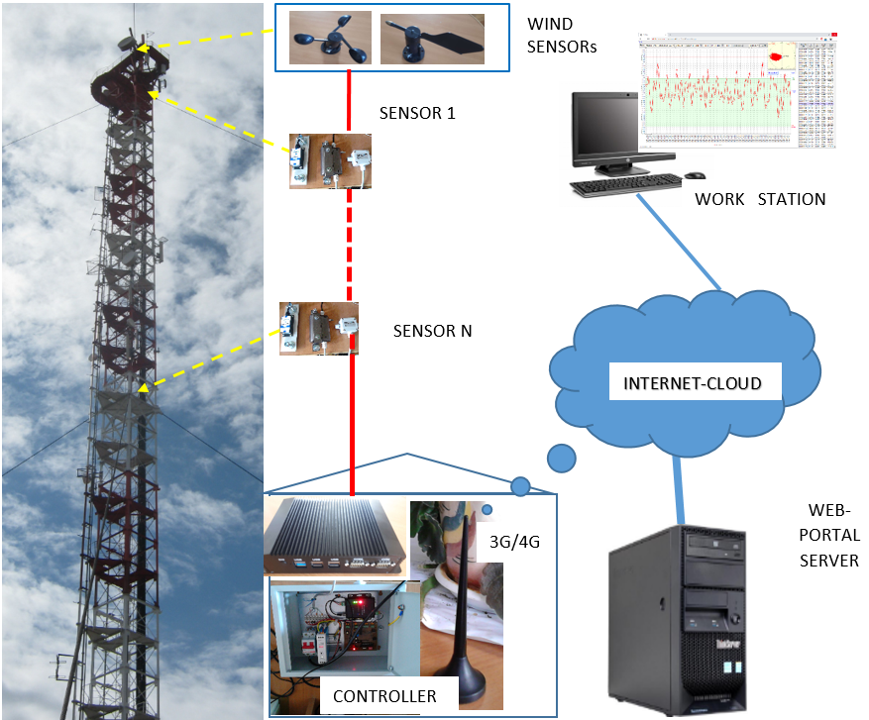
Fig. 1

User interface

The main user interface (Work Station) window is shown in Figure 2.

DATA DIRECTORIES TRAFFIC SUPERINTENDENT ADMINISTRATION
Data directory editing Alarms Configurations
Track Viewer
STATISTICS USER INTERFACE LANGUAGES
Chart English Русский Romană
Verticality
Fig. 2

The main functions of the System are STATISTICS-Chart and STATISTICS-Verticality, Fig. 3,4.

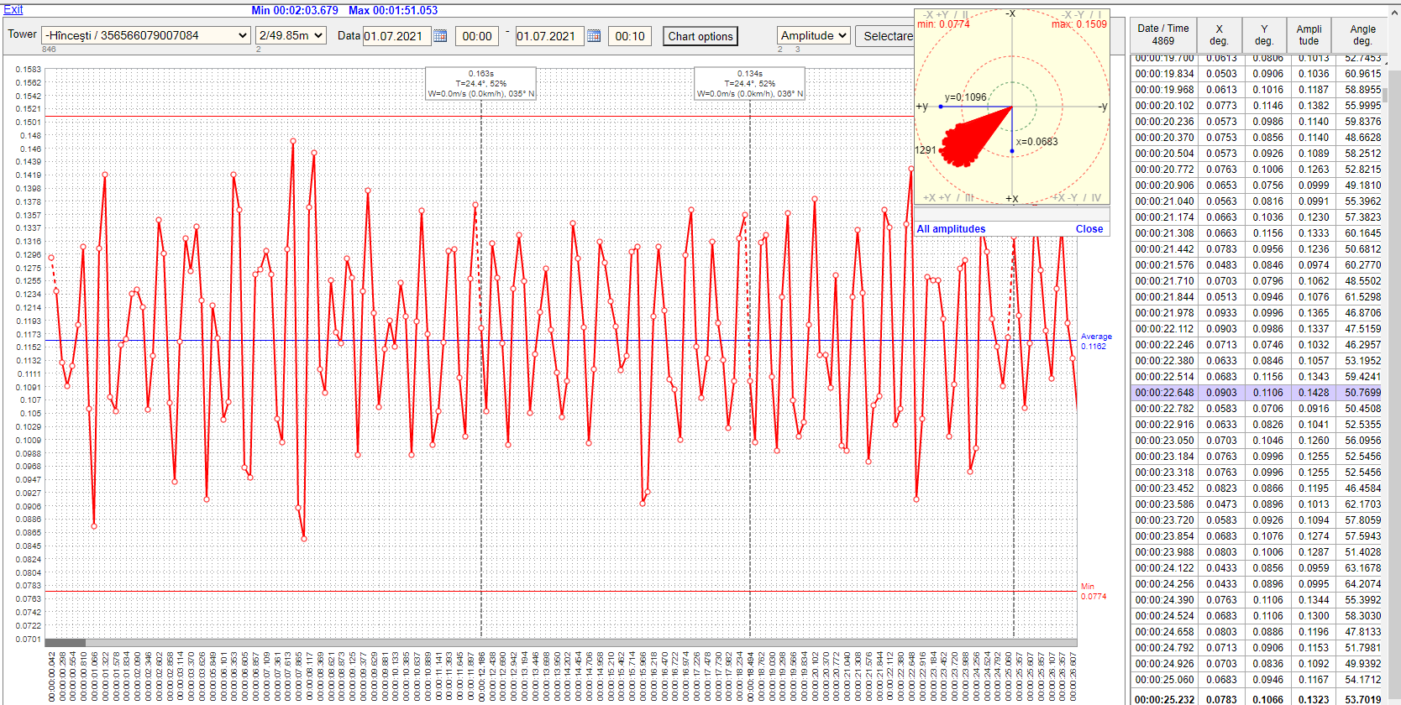

Fig. 3
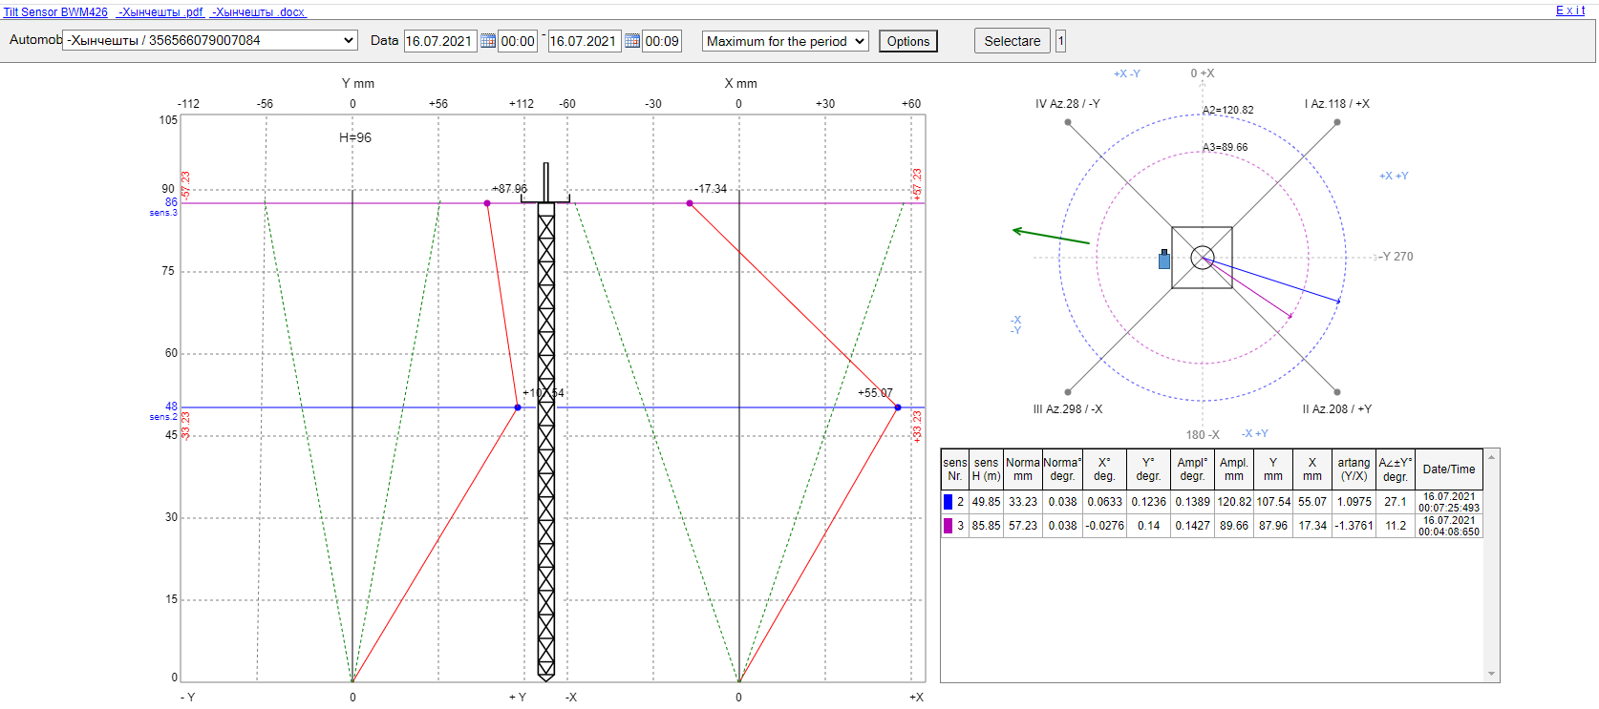
Fig. 4

Fig. 5 shows alarms for vertical or vibration violation of the mast / tower.

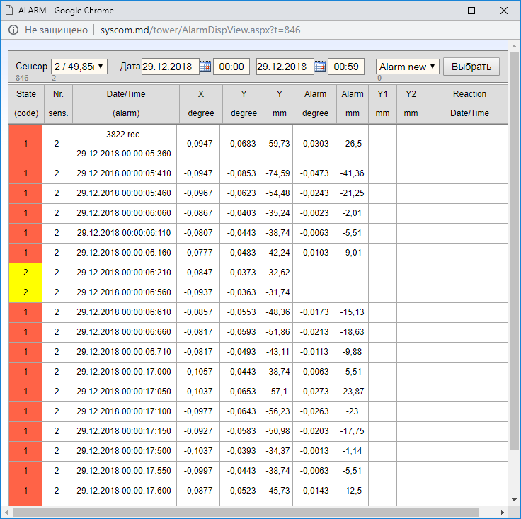
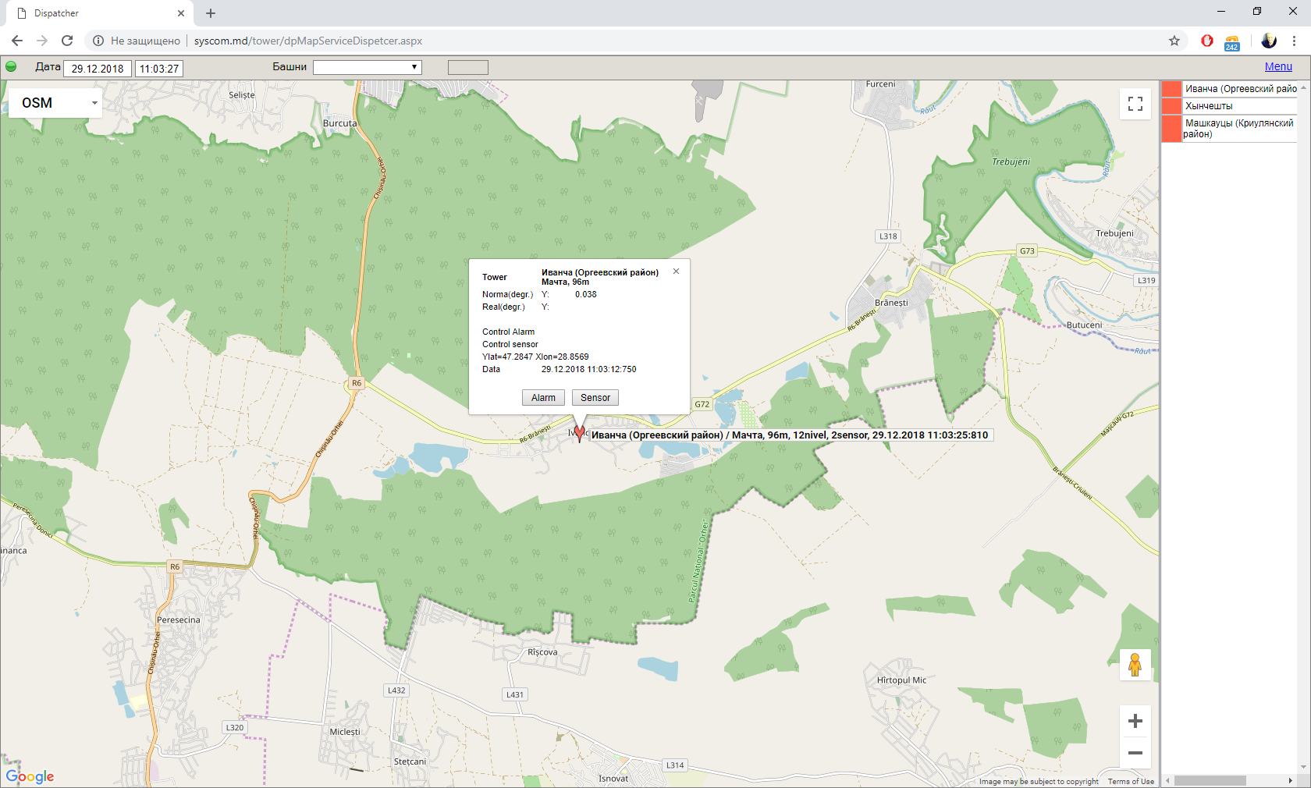
Fig. 5

Basic parameters
Technical specifications
Name | Specification
Periodicity of displaying information from sensors | 100-200 milliseconds
Displaying information on WORKSTATION | - Timeline of fluctuations  - Typical scheme of geodetic measurement of verticality  - Pie chart of deviations
Method of transmitting / receiving information | Internet, RS-482
Operating conditions for outdoor components:  - Humidity protection level  - Electromagnetic and lightning protection  - Impact resistance | IP67  GBT17626  2000g, 0.5ms, 3 times
Measuring accuracy
Sensor type | Mean time between failures (MTBF), hour | Accuracy of ASVD, degrees | Operating temperature range
BWM 426 | 30000,0 | 0,02 | -40～85℃
BWS 2000 | 90000,0 | 0,002 | -40～85℃

ASVD implemented in the Republic of Moldova at the state-owned enterprise RADIOCOM.

