SOFTCOM S.A.
Republica Moldova, Chişinău MD-2038, Decebal 76
Tel/Fax (37322)563306; e-mail: cvv@syscom.md

FISCAL TAXI SYSTEM STF
Included in United registry KKM by Interdepartmental Commission decision
(Monitorul Oficial Nr. 270-274 of 12 September 2014)

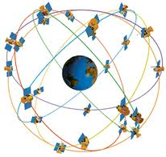
GPS

INTERNET/3G/4G

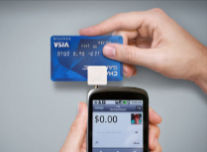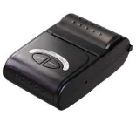
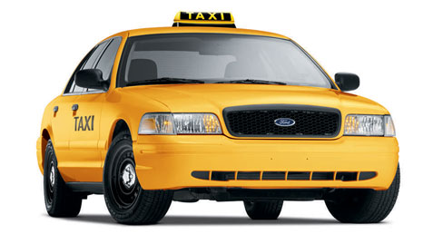

Chisinau-2014

Fiscal Taxi System STF is designed for the calculation of the services and accepting the payment from the taxi passengers and also for the financial accounting.
STF consists of two main parts: the Mobile unit STF-M (in every car) and the Office (stationary) unit STF-S (one for many cars).
STF-M consists of the following parts:

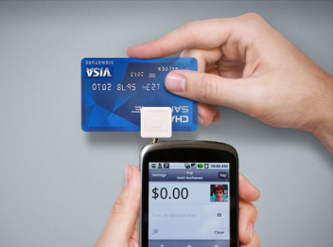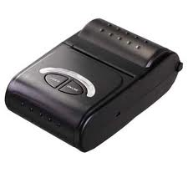
INTERNET/3G/4G

- Smartphone: Android 4.0 and higher, Touchscreen, GPS, External memory card SDHC 4 GB, SIM (USIM) Internet, Bluetooth, STF-M-SW01 software.
- Onboard printer: Bluetooth ticket printer.
- Bank card reader.
- Software for mobile part: STF-M-SW01.

STF-S consists of the following parts:
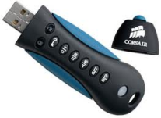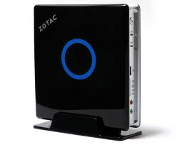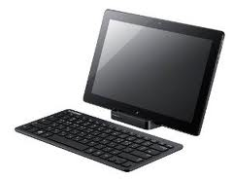
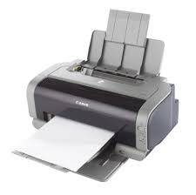
INTERNET

- Hub: Computer ZOTAC ZBOX, Monitor, Keyboard, Office printer.
- Fiscal memory: CORSAIR PADLOCK flash drive.
- Software for stationary part: STF-S-SW01.

The mobile unit STF-M is installed in the taxi cabin directly near the driver. The smartphone is installed in the special holder and is charged from an onboard battery (+12V, +24V) via USB. The smartphone must have a SIM-card (USIM) with the Internet traffic not less than 50 MB per month. Onboard printer is installed in a comfortable place and is connected to smartphone wirelessly (Bluetooth).
The stationary (office) part STF-S is installed in the office and is connected to the Internet via a Local network or wirelessly via Wi-Fi protocol (TCP/IP).

Advantages
- Conversion to the tariff-based (“civilized”) account and taxi services payment system with the ticket release to the client.
- Possibility of the electronic card payment.
- Automated monitoring of clients accounting.
- Possibility of integration of the Automated System of Order Execution ASOE.

Technical specifications of the STF

NAME | SPECIFICATION
- Count of mobile parts connected to the Hub | Up to 1000
- Cash operations  - Payment with the cash  - Payment with the bank cards  - Printing payment tickets | MDL  Master Card, Visa and other  Thermal printing
- Tickets count filling the entire fiscal memory | Not less than 80*10⁶
- Storage time of the records in the fiscal memory | Not less than 7 years
- Communication channels  - Mobile parts with the office part  - Corporative  - Fiscal | Internet- GPRS/3G/4G  Internet- TCP/IP, Wi-Fi  Internet
- Reports  - Individual  - Group | For each mobile unit separately for an arbitrary time interval  For selected group of mobile units for an arbitrary time interval
- Software  - Operating system of the mobile unit  - Operating system of the office Hub  - Application software of the mobile unit  - Application software of the office unit | Android 4.0 and higher  Windows 7  STF-M-SW01  STF-S-SW01.
- Warranty period | 3 years

Automated System of Orders Execution (ASOE) is supplied optionally to provide an entire cycle of taxi service: accepting order – search for a car – order execution – payment. ASOE works on the same platform as the STF.

Main functions of the ASOE:
- Input of clients orders in the system;
- Automated selection of the car for the given order (by the minimal trip distance/time to the client criteria);
- Order transfer to the driver of the selected car;
- Calculating the trip price and release of the ticket;
- Administration of the reference data;
- Generating and printing the reports for orders and tickets.

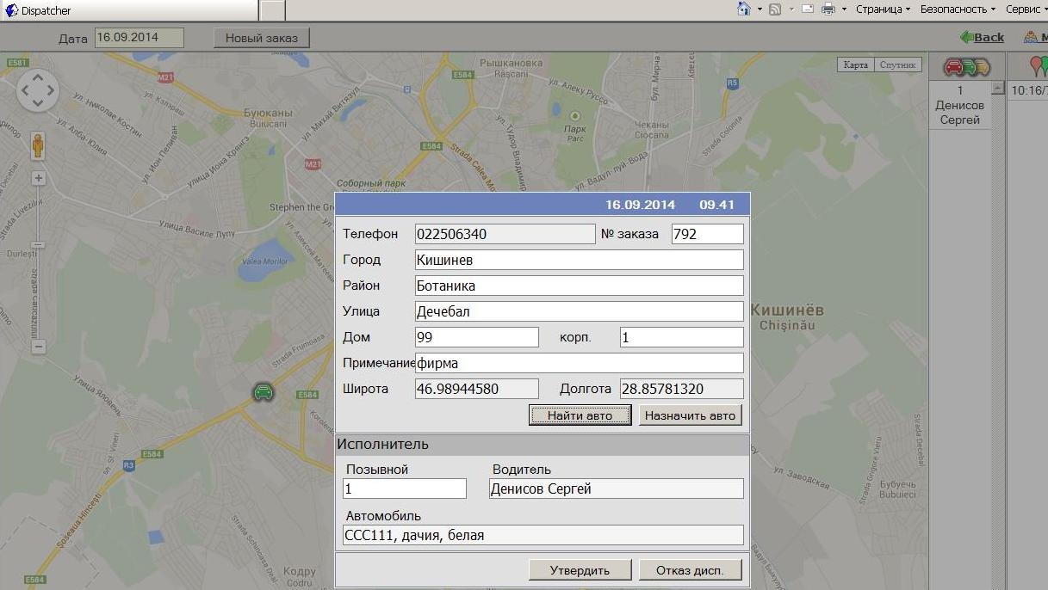

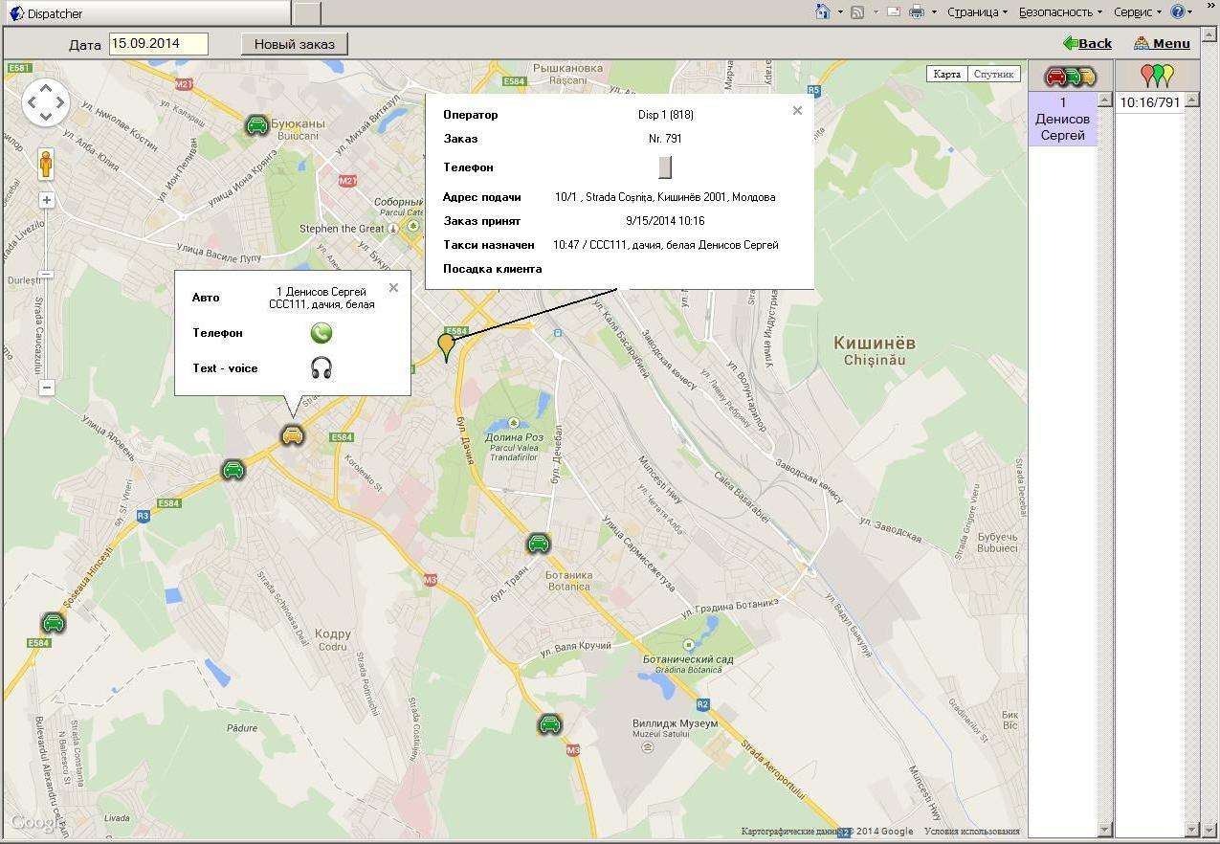

Integration
Our specialists will provide an organization of the integration and the operating of the Fiscal Taxi System STF on your enterprise.

